**CSE313: Big Data Analytics – Lab Assignment 3**  1

MongoDB

*Use MongoDB command line for all the assignments.*

1. Create a database called *class*.

$ sudo service mongod start

$Mongo // start MongoDB and Login

Use class // create a database called class

C:\Users\HP\AppData\Local\Microsoft\Windows\INetCache\Content.Word\1.png

1. Create a collection called *students* and Insert few students with their *name, address* and *age*

db.createCollection("students") // create a collection called students

db.students.insert({name :'Joe', address:'Suzhou', age:'18'})

db.students.insert({name :'Jason', address:'Beijing', age:'20'})

db.students.insert({name :'Miffy', address:'Chengdu', age:'22'})

db.students.insert({name :'Tako', address:'Harbin', age:'24'})

db.students.insert({name :'Nanase', address:'Osaka', age:'26'}) // insert five students with details

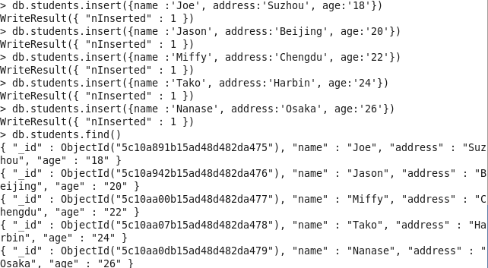

1. Find students with a given *address*. Ex: Find all student whose *address* is Beijing then update the students address to Suzhou.

db.students.update({address:'Beijing'},{"$set" : {address:'Suzhou'}})

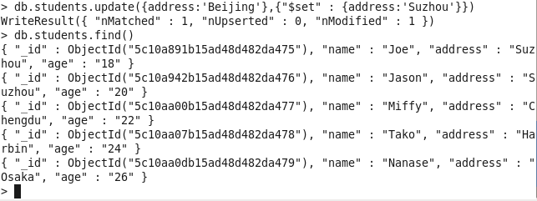

1. Print all students’ *name* and *address* but not *age* and *_id*.

db.students.find({},{'_id':0,'name':1,'address':1})

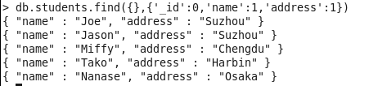

1. Find all the students *age* between age 20 to 25.

db.students.find({'age':{'$gte':'20','$lte':'25'}})

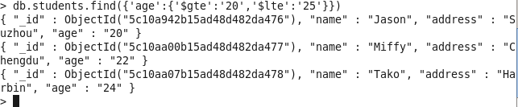

1. Sort the students by the age (low to high) and print first 3 students.

db.students.find().sort({age:1}) // sort the students by the age (low to high)

db.students.find().limit(3) // print first 3 students

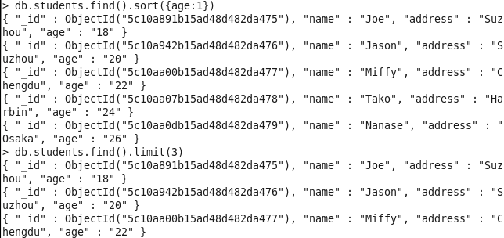

1. Update the *students* collection such a way that same student *name* can not be inserted twice in two records (i.e. ensure student name is the unique in the collection)

db.students.createIndex({'name':1}, {'unique':true})

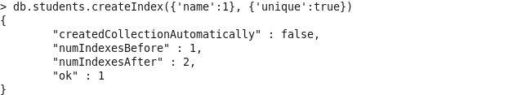

Check:

db.students.insert({name :'Nanase', address:'Shanghai', age:'26'})

// insert a student with the same name as the last student inserted

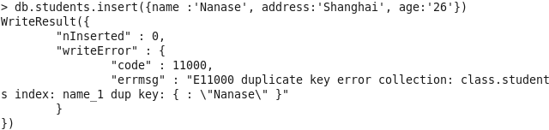

8. Consider a student Jack Ma’s address is an embedded document as shown below:

{

"name": "Jack Ma", "address": {

"street": " 111 Ren'ai Road ", "city": "Suzhou",

"state": "Jiansu"

}

}

Insert this document into MongoDB.

Write a query to search for all students who lives in the city *Suzhou* and name is *Jack Ma*. Remember *city* field is inside address document.

document = { "name": "Jack Ma", "address": { "street": " 111 Ren'ai Road ", "city": "Suzhou", "state": "Jiansu" }} // define the document

db.students.insert(document) // insert

db.students.find({'name':'Jack Ma','address.city':'Suzhou'})

//query with combine inside field

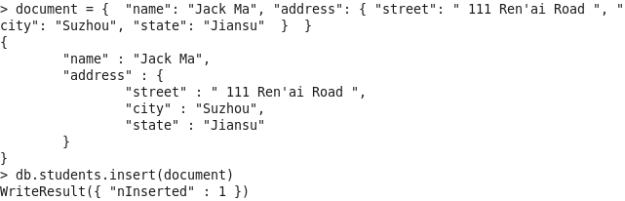

C:\Users\HP\AppData\Local\Microsoft\Windows\INetCache\Content.Word\82.png